Engineers in Training at All Saints
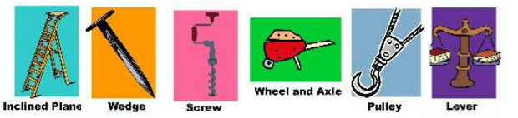

SIX SIMPLE MACHINES-
“EASY PEASY, OUR WORK IS DONE!”

Students will recognize and discover simple machines. They will
find that working with tools means putting the “Six Simple Machines” into action (wheel&axle, inclined plane, wedge, lever, pulley, and screw). Students will enjoy tasting the product from working with several of their simple machines.

Grades K – 2

- Thursdays, 4:00 – 5:00pm in Room 4
- Limited to first 10 paid registrations
- Cost: $15
- January 10 - February 14
(6 weeks)

Taught by Ms. Collette Roundtree, M.A.T., a science teacher for 13yrs. and
STEM engineering teacher for 14yrs.

Please register my child for “Engineers in Training”. I have enclosed the $15 registration fee.

________________________________________________________
Child’s Name Grade

________________________________________ ______________
Parent Signature Date

