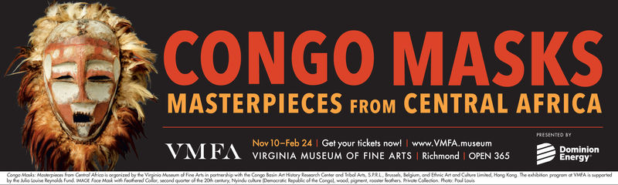
Explore the world of African art and craft your own Congo-inspired mask! Learn about the importance of these masks in culture as well as how artists like Pablo Picasso were inspired by African masks.

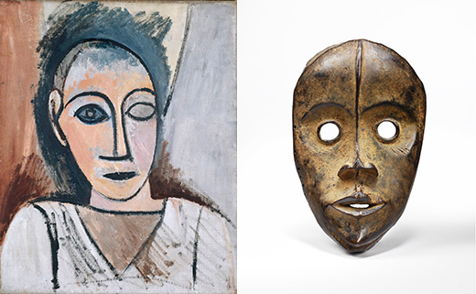

Students will visit the VMFA to learn and gather inspiration,
then will sketch and build incredible pieces that meld individual
artistic flair with traditional styles used by African artists.

Grades 3 – 5

- Fridays, 3:30 – 5:00 pm
- Limited to first 12 registrations
- Cost: $30
- January 11 – February 15 (6 weeks)
Museum visit Jan 18th at 3:30

Taught by Mrs. Cynthia Myron-Hackett

Please register my child for Congo Masks. I have enclosed the $30 registration fee.

________________________________________________________
Child’s Name Grade

________________________________________ ______________
Parent Signature Date

*Upon students’ acceptance to this activity, an additional Field Trip Form will be sent home, and must be signed before the first meeting.

