Engineers in Training at All Saints
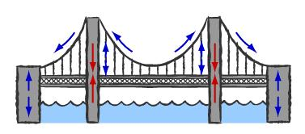

CIVIL ENGINEERING-
“Bridging from Here to There!”

Students will be able to use entrepreneur skills to create a civil engineering company that will design and build “toothpick bridges”. Then the strength of the bridges will be tested for its ability to withstand a maximum load.

Grades 6 – 8

- Wednesdays, 4:00 – 5:30pm in Room 4
- Limited to first 12 registrations
- Cost: $15
- March 13- April 17
(6 weeks)

Taught by Ms. Collette Roundtree, M.A.T., a science teacher for 13yrs. and
STEM engineering teacher for 14yrs.

Please register my child for Chemical Engineering. I have enclosed the $15 registration fee.

________________________________________________________
Child’s Name Grade

________________________________________ ______________
Parent Signature Date

