Contemporary & African Art

Explore the world of Contemporary and African Art and craft your own culturally inspired mask! Learn about the importance of masks in culture as well as how artists like Pablo Picasso were inspired by African art and masks.

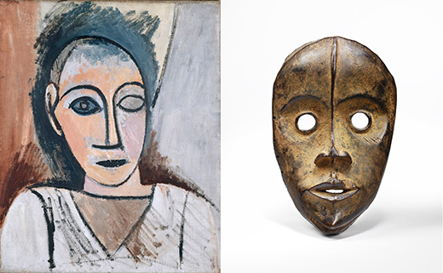

Students will visit the VMFA to learn and gather inspiration,
then will sketch and build incredible pieces that meld individual
artistic flair with traditional styles used by African artists.

Grades 3 – 5

- Thursdays, 3:30 – 5:00 pm
(Thursdays: March 14th, 21st, 28th, April 4th, 11th & Wednesday April, 17th to accommodate Spring Break)

- March 14 – April 17 (6 weeks)
Museum visit tentatively visit March 21st at 3:30pm
- Cost: $25
Cost includes bus & museum fees, and all supplies

- Limited to first 12 registrations

Instructor: Mrs. Cynthia Myron Hackett (artist, educator, All Saints parent)

Please register my child for African and Contemporary Art. I have enclosed the $25 registration fee.

________________________________________ ______________
Child’s Name Grade

________________________________________ ______________
Parent Signature Date

*Upon students’ acceptance to this activity, an additional Field Trip Form will be sent home, and must be signed before the first meeting.

