Engineers in Training at All Saints

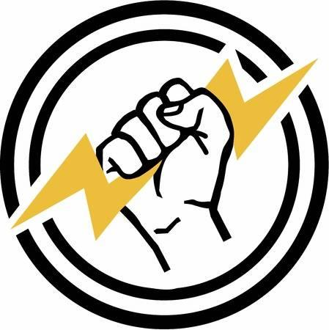
ELECTRICAL ENGINEERING-
“Circuits, Switches, and Wires, OH MY!!!”

Students will understand that electricity is a form of energy that moves. They will create “static electricity”, design an “electromagnet”, and build “series circuits” using snap kits.

Grades K - 2

- Thursdays, 4:00 – 5:00pm in Room 4
- Limited to first 12 registrations
- Cost: $15
- March 14 - May 2
(6 weeks)

Taught by Ms. Collette Roundtree, M.A.T., a science teacher for 13yrs. and
STEM engineering teacher for 14yrs.

Please register my child for Chemical Engineering. I have enclosed the $15 registration fee.

________________________________________________________
Child’s Name Grade

________________________________________ ______________
Parent Signature Date

