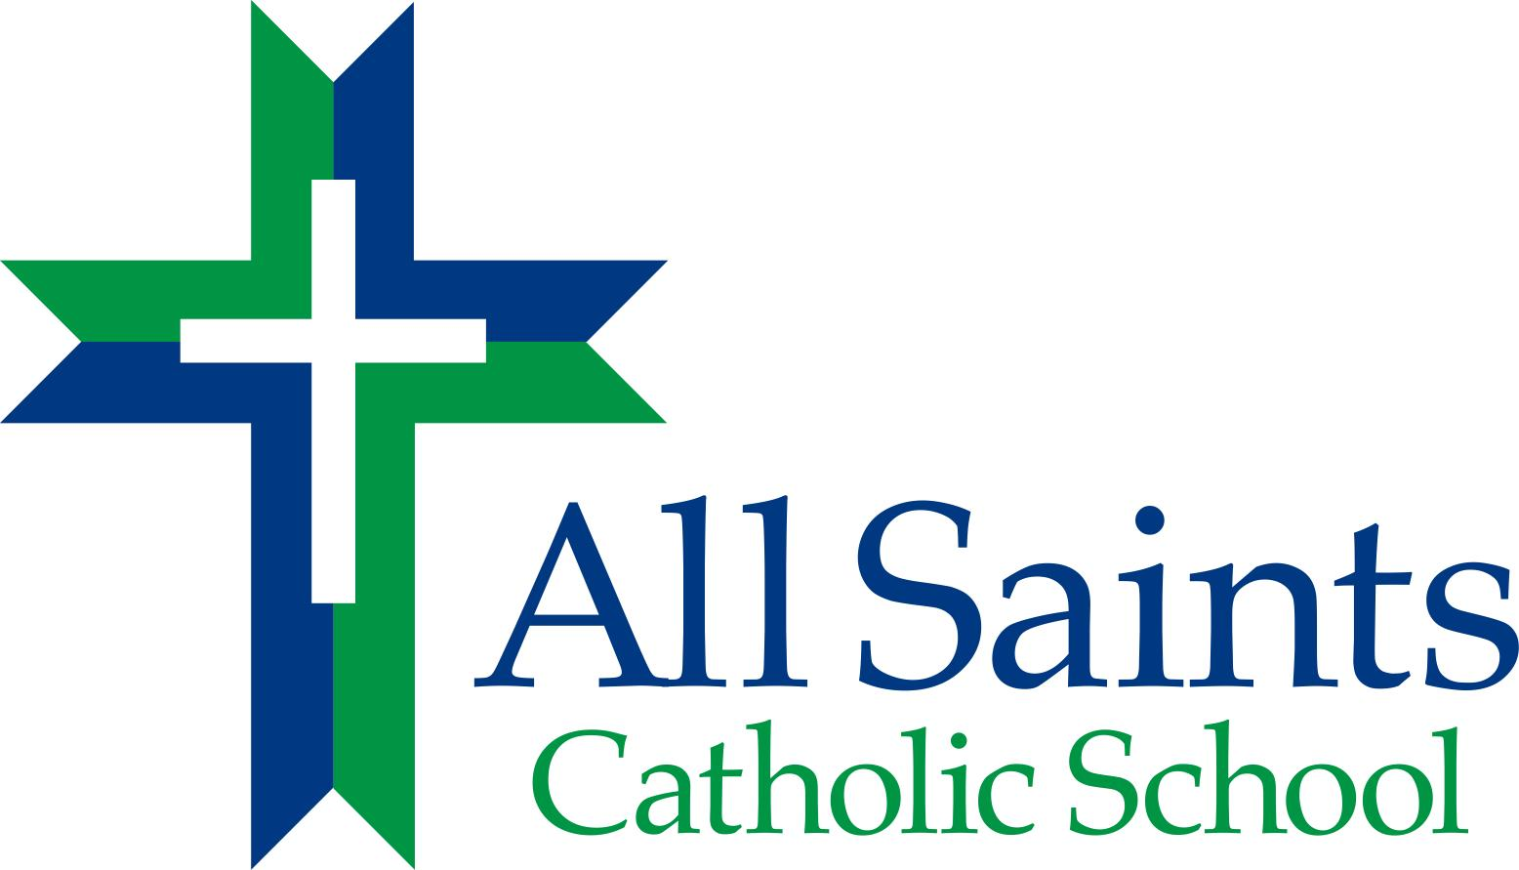

After School Program

3418 Noble Avenue
Richmond, Virginia 23222
804-329-7524
804-329-4201 Fax
www.allsaintsric.org

PARENT HANDBOOK
2017-18

Table of Contents

Administration ……………………………………………………………… 3

Policies and Procedures
Operating Information ……………………………………………….. 4
After School Program Fees

Termination of Services for ASP . . . .…………………….…..…….. 5
Daily Schedule
Arrival and Departure Procedures ………………………………………6
Late Pick Up Fee/Procedures
Emergency Late Pick Up Procedures
Snack Policy

Medication
Emergencies …………………………………………………………… 7
Attendance
Traffic Procedures
Visitation by parents or guardians to ASP
Insurance Plan

Code of Behavior ……………………………………..…………………………8
Disciplinary Actions …………………………………………………………………9

Safety ………………………………………………………………………………10
ASP Children’s Records

Licensing Information for Parents About Child Day Programs…11

ADMINISTRATION

Bishop of the Catholic Diocese of Richmond – Bishop Frances X DiLorenzo

Office of Catholic Schools Superintendent - Ray Honeycutt

Administrators/Directors of the After School Program
Wanda Wallin – Principal
Treena Leecost – Assistant Principal

Child Care Workers and Designated Grade Responsibilities
Leslie Gray – PK & K
Maurice Gwathmey– Grades 1 & 2
Brenda Coleman – Grades 3 - 5
Deborah Branch – Grades 6 – 8
Susan Ferguson – Floater
Mary Nobles-Jackson – Office Assistance

Policies and Procedures

Operating Information
ASCS offers an after school program for its students from the end of school to 6pm each school day. The After School Program operates ONLY when school is in session (see school calendar at www.allsaintsric.org), and is only open to enrolled All Saints Catholic School students.
The program has several objectives:
- Provide a safe, caring, physically active, and fun environment for students after school
- Provide a time for homework completion. Homework assistance available from program leaders as time allows.
- Provide a healthy snack.
- Offer a variety of specialty activities each week such as organized outdoor and indoor games, organized art projects, community service projects, dance, clubs, sports, etc.
- Uphold the mission and the philosophy of ASCS (see Appendix).
The After School Program will operate from 3:15 to 6:00 PM on regular school days (2:15pm to 6pm on Wednesdays) for All Saints Catholic School students only.

Parents desiring after school care need to complete the required student data.

After School Program Fees

One Child - $45.00 per week – 3, 4, or 5 days
Each additional child per family - $22.50 per week
$11.00 per day per child – 1 or 2 days ONLY

Fees are due on the Friday at the end of that week for which service has been provided. Payment may be made on-line through your Parent Web account or by check, cash or money order in the school office. A late fee applies for all children picked up after 6:00 PM.

Failure to pay fees in a timely manner could result in termination from the program.

Termination of Services for ASP

Services for After School Program care could be terminated for the following reasons:
- Failure to pay fees in a timely manner.
- Failure of child to follow the Code of Behavior.
- Failure of parent/guardian to complete all necessary forms.
- Failure of parent/guardian to promptly pick up child in non-emergency situations over an extended period of time after consultation with ASP staff.

Daily Schedule

3:00 – 3:30 Check-in and Snack

3:30 – 3:45 Silent Reading

3:45 – 4:45 Homework

4:45 – 6:00 Outside Play/Craft Activities/Board Games

In case of inclement weather, outside play will be in the gym.

Younger grades (PK – 2) will have a shorter homework time. Reading time for PK/K will be teacher read aloud.

Room Assignments:
PK/K Room K on MWF, Room PK on TR
1&2 Room 1 on MWF, Room 2 on TR
3 – 5 Room 7

Arrival and Departure Procedures for Children

Arrival To After School Program

Students remaining at the end of dismissal will be escorted by their teacher to the cafeteria to be signed-in to ASP.

Departure From the After School Program

All parents will enter the building through the main doors at the office in order to sign their child out of the After School Program. School personnel or ASP staff will call on the intercom for the student to come to the office for dismissal. Children must be picked up from the ASP by a parent or authorized pick-up person. The children must be signed out of the ASP. All children must be picked up by 6:00 PM. A valid driver’s license or other acceptable identification will be required for pick-up by authorized persons. A copy of the Pick-Up Authorization for each ASP student is available in the office to be used to verify those who are authorized to pick-up a student from the After School Program.

Late Pick Up Fee and Procedures

Parents are to pick-up their children by 6:00 PM. A late pick-up fee of $1 per minute will be charged after 6:00 PM for every minute that the parent is late, after 6:00 PM. This money is due at the time of pick up or parents will be appropriately billed. Excessive lateness could result in termination from the program. If a child has not been picked up after a reasonable period of time and all emergency contacts have been exhausted, the ASP staff will notify the police or social services.

Emergency Late Pick Up Procedures

When a child is not picked up due to emergency situations, which would include severe weather conditions or natural disasters, the All Saints After School Program leader will remain with the student until the child has been picked up by an authorized person. Every effort will be made to contact the parent via all available numbers to ensure them of the safety of their child.

Snack Policy

Students may bring a snack to eat during snack time or may purchase a snack. Snacks are $0.75 each. Students must use cash to purchase snacks.

Medication

All medication will be stored in the school office. Approved After School Program staff will administer medication. All medication must be in the original container and accompanied the Written Medication Consent Form from parent/guardian for administering the medication. ASP staff is to record the administration of the medication on the appropriate form. Appropriate forms are available in the school office and in the parent handbook.

Emergencies

Parents are to listen to WRVA, Channels 6, 8, or 12 for emergency closings due to inclement weather conditions or any other emergencies. All Saints Catholic School will also notify you by phone and email via our Parent Alert system given internet connections are available. Program Leaders will follow our Crisis Management Plan in the event of any type of emergency.

Attendance

The designated ASP childcare worker for each group of students is responsible for the attendance of its students, making sure that all students are accounted for at all times. Students are to report to the ASP before going to club meetings, etc. in the building.

Traffic Procedures

Please drive slowly and safely on the school ground. Enter the Noble Street entrance to the playground and park in the area where the children are not playing. At no time are parents to leave the vehicle running and unattended. Please turn your car off before leaving the vehicle. Please lock your car.

Visitation by parents or guardians to ASP

A custodial parent or guardian shall be admitted to any child day program (Code of Virginia §63.2-1813). Parents who desire to volunteer to work with the children must have completed the VIRTUS program as prescribed by the Catholic Diocese of Richmond.

Insurance Plan

Insurance coverage is mandatory for every student attending All Saints Catholic School. This includes all school-sponsored activities. Therefore, all students enrolled in the After School Program are covered by school insurance.

Code Of Behavior

Students of All Saints School are expected to maintain good citizenship. Students are to display a cooperative attitude, respect the rights and opinions of others, respect property, accept responsibility, show growth in self-control, and take pride in personal appearance and actions.

In order for the student to achieve the above, parental involvement and support of all school policies is expected. ASP leaders, parents, and students must work cooperatively to foster and maintain a positive care environment. Disruptive student behavior is subject to disciplinary action by the program leader, assistant principal, principal, or principal designee.

- Display a cooperative attitude.
Students are to be courteous, have appropriate manners, and behave orderly at all times. Students are expected to be courteous, respectful and attentive to program leaders and other adults. Students are expected to show respect and consideration for their classmates. The student's cooperation is expected. Students will acknowledge and welcome visitors to All Saints School. Defiance, disobedience, attitude, and inappropriate body language will not be tolerated.

- Respect the rights and opinions of others.
Students are to demonstrate proper respect for self and others in words and actions. Proper language is expected at all times. Inappropriate or abusive language (verbal or written) will not be tolerated. Inappropriate literature or illustrations, this includes diaries, which disrupt the educational process, will not be allowed.

- Respect property.
Respect and care of books, materials, and all school property is expected. Respect for other students’ property is also expected. Damage to any of these will require full restitution. The use of any type of unauthorized electronic devices, such as but not limited to, cell phones, pagers, beepers, ipods, CD players, digital cameras and laser pointers, is not permitted by students. Such items will be confiscated by school administration and returned to parents or guardians. Such items found in a student’s possession for a repeated time can result in the student being sent home for the remainder of the school day and issued a one day home suspension on the next school day.

- Accept responsibility.
Honesty, trustworthiness, and integrity with oneself and others are expected. Lying, cheating, stealing, plagiarism, falsification, etc. are unacceptable. Care of one's body by avoiding all harmful substances such as cigarettes, alcohol, and drugs is expected. Possession of such harmful substances is prohibited and is grounds for expulsion. All medication is to be kept in the school office. Weapons of any kind are prohibited and possession of such items is grounds for expulsion.

- Show growth in self-control.
Use non-violent techniques to solve problems. Fighting (intentional hitting, scratching, shoving, biting, throwing of objects, etc., is not permissible). Instigating fighting or conflicts (comments, actions, or messages) is not permissible. Cursing, threatening, using abusive language, bullying, teasing, hazing, or other acts of intimidation will not be tolerated. Excessive talking interferes with the learning process and will not be tolerated.

- Take pride in personal appearance.
Adherence to the dress code is mandatory. Any inappropriate items will be confiscated and returned to the parent. Inappropriate hair styles, gum, false nails, nail polish, headscarves, hats, and any other items, which distract others from the learning process, inhibit participation, or endanger self or others in school activities are not allowed.

DISCIPLINARY ACTIONS

Our chief responsibility is to provide a safe and secure learning environment for each child. Parents are expected to discuss the code of behavior and its consequences with their child. The school and home must work together to provide strong discipline and a safe learning environment for the school. The appropriate disciplinary action, in no particular order, will be taken by the administration to resolve issues of school discipline.

- Student Conference
- Contact parent (verbal and/or written).
- Conference with parent, program leader and/or administration.
- Parent pick-up child immediately from school.
- Confiscation.
- Work detail.
- Restitution.
- Counseling.
- Mediation/Conflict Resolution.
- Temporary or permanent suspension from the ASP
- Suspension from school
- Three suspensions (In-school and/or home) are an automatic expulsion.
- Expulsion.

Serious infractions, as deemed by the administration, may result in immediate expulsion from the school. (An example of a serious infraction would be the possession of drugs or weapons; endangering the safety of the school community and any of its members; habitually violating the code of behavior)

Students who earn a suspension from school cannot earn Honor Roll Status and are not eligible for the All Saints Catholic School Advisory Board Academic Scholarships or tuition assistance.

Safety

ASCS follows an injury prevention plan, a playground safety plan, and an emergency preparedness plan. Only staff trained in medical administration may administer medication with written consent of the parent.

ASP Children’s Records

Each child’s folder will contain: ASP Registration Form and Pick-up Authorization Form.

The school office will maintain: ASCS Registration Form, Student Data Sheet, Health Information Sheet, and Immunization Form

Failure to complete all necessary forms may result in termination from the program.

Licensing Information For Parents About Child Day Programs

The Commonwealth of Virginia helps assure parents that child day programs that assume responsibility for the supervision, protection, and well being of a child for any part of a 24-hour day are safe. Title 63.1, Chapter 10 of the Code of Virginia gives the Department of Social Services authority to license these programs. While there are some legislative exemptions to licensure, licensed programs include child day centers, family day center systems, and family day systems. The state may also voluntarily register family day homes not required to be licensed.

Standards for licensed child day centers address certain health precautions; adequate play space, and a ratio of children per staff member, equipment, program, and record keeping. Criminal records checks and specific qualifications for staff and most volunteers working directly wit children are also required. Standards require the facility to meet applicable fire, health, and building codes.

Compliance with standards is determined by announced and unannounced visits to the program by licensing staff within the Department of Social Services. In addition, parents or other individuals may register a complaint about a program, which will be investigated if it violates a standard.

If you would like additional information about the licensing of child day programs or would like to register a complaint, please contact the Central Regional Office of Social Services, 1604 Santa Rosa Road, Suite 130, Richmond, Virginia 23229-5008, 804-662-9743.

