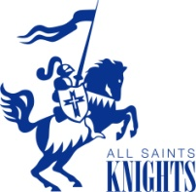 PE Uniform Order Form

Each student is expected to be in proper PE uniform on his/her assigned PE day beginning August 27, 2018. Orders will be delivered to students in homeroom during the first two days of school.
Student Name ________________________________________ Grade ________
Please check the correct boxes and enter the totals.
Shorts
Youth ($10) _____Small _____Medium _____Large
Adult ($10) _____Small _____Medium _____Large _____XL _____XXL Shorts Total $____________

Shirt
Youth ($7) _____Small _____Medium _____Large
Adult ($8) _____Small _____Medium _____Large _____XL _____XXL Shirt Total $____________

Sweatshirt
Youth ($13) _____Small _____Medium _____Large
Adult ($15) _____Small _____Medium _____Large _____XL _____XXL Sweatshirt Total $____________

Sweatpants
Youth ($13) _____Small _____Medium _____Large
Adult ($15) _____Small _____Medium _____Large _____XL _____XXL Sweatpant Total $____________

OR

Complete Set (all four pieces)
Youth ($43) _____Small _____Medium _____Large
Adult ($48) _____Small _____Medium _____Large _____XL _____XXL Outfit Total $____________

Order on-line (visit our website – www.allsaintsric.org and view the parent info page) or bring this form by the school office after August 1, 2018 and pick-up in person. Summer office hours are Monday – Friday, 8 to 4pm.

