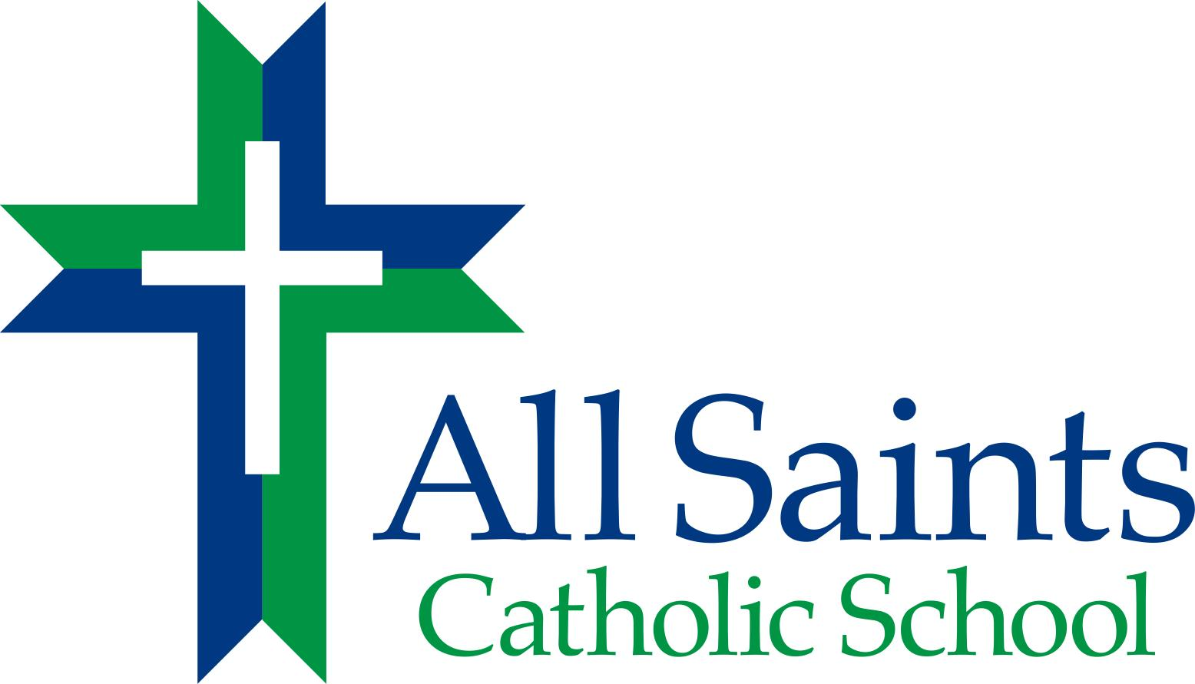

After School Program

3418 Noble Avenue
Richmond, Virginia 23222
804-329-7524
804-329-4201 Fax
www.allsaintsric.org

PARENT HANDBOOK
2018-19

Table of Contents

Administration

Policies and Procedures
Operating Information
After School Program Fees
Termination of Services for ASP
Daily Schedule
Arrival and Departure Procedures
Late Pick Up Fee/Procedures
Emergency Late Pick Up Procedures
Snack Policy
Sick Policy
Medication
Emergencies
Attendance
Traffic Procedures
Visitation by parents or guardians
Insurance Plan

Code of Behavior
Disciplinary Actions
Safety
ASP Children’s Records

Licensing Information for Parents About Child Day Programs

School Mission and Philosophy

ADMINISTRATION

Bishop of the Catholic Diocese of Richmond – Bishop Barry C. Knestout

Office of Catholic Schools Superintendent - Ray Honeycutt

Administrators/Directors of the After School Program
Mrs. Wanda Wallin – Principal

Child Care Staff and Designated Grade Responsibilities
Yohanny Lizardo – PK & K
Maurice Gwathmey– Grades 1 & 2
Brenda Coleman – Grades 3 - 5
Deborah Branch – Grades 6 – 8
Jessica Gilman – Activity Coordinator & Floater
Mary Nobles-Jackson – Office Assistance

All childcare teachers have previous experience caring for children. They have undergone background checks, are Virtus trained in being a mandatory reporter for child abuse or neglect, and have CPR and first aid training. Our childcare teachers receive sixteen hours of training in best educational and childcare practices annually. We comply with child-staff ratios set by the Virginia Department of Social Services which are 1:10 for children 4 and 5 years old and 1:25 for children 6 years plus.

Policies and Procedures

Operating Information
ASCS offers an after school program for its students from the end of school (typically 3pm) to 6pm each school day. The After School Program operates ONLY when school is in session (see school calendar at www.allsaintsric.org), and is only open to enrolled All Saints Catholic School students.
The program has several objectives:
- Provide a safe, caring, physically active, and fun environment for students after school
- Provide a time for homework completion. Homework assistance available from program leaders as time allows.
- Provide a healthy snack.
- Offer a variety of specialty activities each week such as organized outdoor and indoor games, organized art projects, community service projects, dance, clubs, sports, etc.
- Uphold the mission and the philosophy of ASCS
Parents desiring after school care need to complete the required student data form.

After School Program Fees

One Child - $50.00 per week
($12 for 1 day, $24 for 2 days, $36 for 3 days and $50 for 4 or 5 days)
Each additional child per family – 50% discount

Fees are due on the Friday at the end of the week for which service has been provided. Payment may be made on-line through your Parent Web account or by check, cash or money order in the school office. A late fee applies for all children picked up after 6:00 PM.

Failure to pay fees in a timely manner could result in termination from the program.

Termination of Services for ASP

Services for After School Program care can be terminated for the following reasons:
- Failure to pay fees in a timely manner.
- Failure of child to follow the Code of Behavior.
- Failure of parent/guardian to complete all necessary forms.
- Failure of parent/guardian to promptly pick up child in non-emergency situations over an extended period of time after consultation with ASP staff.

Daily Schedule

3:00 – 3:30 Check-in and Snack

3:30 – 3:45 Silent Reading

3:45 – 4:45 Homework

4:45 – 6:00 Outside Play/Craft Activities/Board Games

In case of inclement weather, outside play will be in the gym.

Younger grades (PK – 2) will have a shorter homework time. Reading time for PK/K will be teacher read aloud.

Room Assignments:
PK/K Room K on MWF, Room PK on TR
1&2 Room 1 on MWF, Room 2 on TR
3 – 5 Room 6
6 – 8 Room 7

Arrival and Departure Procedures for Children

Arrival To After School Program

Students remaining at the end of dismissal will be escorted by their teacher to the cafeteria to be signed-in to ASP.

Departure From the After School Program

All parents will enter the building through the main doors at the office in order to sign their child out of the After School Program. School personnel or ASP staff will call on the intercom for the student to come to the office for dismissal. Children must be picked up from the ASP by a parent or authorized pick-up person. The children must be signed out of the ASP. All children must be picked up by 6:00 PM. A valid driver’s license or other acceptable identification will be required for pick-up by authorized persons. A copy of the Pick-Up Authorization for each ASP student is available in the office to be used to verify those who are authorized to pick-up a student from the After School Program.

Late Pick Up Fee and Procedures

Parents are to pick-up their children by 6:00 PM. A late pick-up fee of $1 per minute will be charged after 6:00 PM for every minute that the parent is late, after 6:00 PM. This money is due at the time of pick up or parents will be appropriately billed. Excessive lateness could result in termination from the program. If a child has not been picked up after a reasonable period of time and all emergency contacts have been exhausted, the ASP staff will notify the police or social services.

Emergency Late Pick Up Procedures

When a child is not picked up due to emergency situations, which would include severe weather conditions or natural disasters, the All Saints After School Program leader will remain with the student until the child has been picked up by an authorized person. Every effort will be made to contact the parent via all available numbers to ensure them of the safety of their child.

Snack Policy

Students may bring a snack to eat during snack time or may purchase a snack. Snacks are $0.75 each. Students must use cash to purchase snacks.

Sickness
Please do not send a sick child to school. If your child has a fever, do not send them to school. When a child becomes sick at school, we will contact the parent (guardian) for immediate pick-up. Please notify the school office if your child has contracted an infectious illness, such as pink eye, chicken pox, etc.

If your child has a serious injury at school, we will notify the parent (guardian) as quickly as possible. Minor scratches and cuts, which require a simple band-aid, will be handled in our clinic. School personnel may call to make you aware of an injury, which might require further monitoring or attention. Please make sure that your child’s health form is up-to-date. Please notify the school office of any changes in work, home, and cell telephone numbers.

Medication

All medication will be stored in the school office. Approved After School Program staff will administer medication. All medication must be in the original container and accompanied the Written Medication Consent Form from parent/guardian for administering the medication. ASP staff is to record the administration of the medication on the appropriate form. Appropriate forms are available in the school office and in the parent handbook.

Emergencies

Parents are to listen to television Channels 6, 8, or 12 for emergency closings due to inclement weather conditions or any other emergencies. All Saints Catholic School will also notify you by phone, text and email via our Parent Alert system given internet connections are available. Program Leaders will follow our Crisis Management Plan in the event of any type of emergency.

Attendance

The designated ASP childcare worker for each group of students is responsible for the attendance of its students, making sure that all students are accounted for at all times. Students are to report to the ASP before going to club meetings, etc. in the building.

Traffic Procedures

Please drive slowly and safely on the school ground. Enter the Noble Street entrance to the playground and park in the area where the children are not playing. At no time are parents to leave the vehicle running and unattended. Please turn your car off before leaving the vehicle. Please lock your car.

Visitation by parents or guardians to ASP

A custodial parent or guardian shall be admitted to any child day program (Code of Virginia §63.2-1813). Parents who desire to volunteer to work with the children must have completed the VIRTUS program as prescribed by the Catholic Diocese of Richmond.

Insurance Plan

Insurance coverage is mandatory for every student attending All Saints Catholic School. This includes all school-sponsored activities. Therefore, all students enrolled in the After School Program are covered by school insurance.

Student Behavior

Our chief responsibility is to provide a safe and secure learning environment for each child. Please refer to the PBIS Manual sent home at the beginning of the school year and published on our website for behavior expectations and typical consequences.

Safety

ASCS follows an injury prevention plan, a playground safety plan, and a crisis management plan. Only staff trained in medical administration may administer medication with written consent of the parent.

ASP Children’s Records

Each child’s folder will contain: ASP Student Data Form and Pick-up Authorization Form.

The school office will maintain: ASCS Re-enrollment form, Student Data form, Health Information sheet, and Immunization form

Failure to complete all necessary forms may result in termination from the program.

Licensing Information For Parents About Child Day Programs

The Commonwealth of Virginia helps assure parents that child day programs that assume responsibility for the supervision, protection, and well being of a child for any part of a 24-hour day are safe. Title 63.1, Chapter 10 of the Code of Virginia gives the Department of Social Services authority to license these programs. While there are some legislative exemptions to licensure, licensed programs include child day centers, family day center systems, and family day systems. The state may also voluntarily register family day homes not required to be licensed.

Standards for licensed child day centers address certain health precautions; adequate play space, and a ratio of children per staff member, equipment, program, and record keeping. Criminal records checks and specific qualifications for staff and most volunteers working directly wit children are also required. Standards require the facility to meet applicable fire, health, and building codes.

Compliance with standards is determined by announced and unannounced visits to the program by licensing staff within the Department of Social Services. In addition, parents or other individuals may register a complaint about a program, which will be investigated if it violates a standard.

If you would like additional information about the licensing of child day programs or would like to register a complaint, please contact the Central Regional Office of Social Services, 1604 Santa Rosa Road, Suite 130, Richmond, Virginia 23229-5008, 804-662-9743.

All Saints Catholic School After-School Program is religiously exempt from licensure with the Virginia Department of Social Services(VDSS). However, we adhere to the standards set forth by the VDSS for religiously exempt child day care providers and we are required to file documentation of code compliance annually to the VDSS. Our facility has annual health, food service and fire inspections. Our program occupancy is a maximum of 100 students.

All Saints Catholic School Mission and Philosophy

MISSION
All Saints is a Catholic school of high moral expectations and academic rigor. We offer a quality pre-kindergarten through eighth grade education in a structured, holistic, disciplined, and safe environment.

Vision: What we will become
All Saints Catholic School will be well known as the “Gem of Northside,”a growing and
dynamic destination Catholic school known for excellence in:

- Preparing students for profound success in high school, college and in their adult lives as highly engaged leaders in a diverse, democratic society,
- Developing the whole child with strong offerings in Christian faith formation, STEM (Science, Technology, Engineering and Math), the arts, language, athletics and meaningful co-curricular and extra-curricular activities,
- Cultivating an exceptionally active and culturally, socio-economically and ethnically diverse student body, and
- Strengthening family bonds with the communities of Ginter Park, Bellevue and beyond, as well as the area Catholic churches.

PHILOSOPHY
- We celebrate the love of God, self, and neighbor; living, teaching, and sharing the Gospel message through daily prayers, religious studies, and activities, infusing students with Catholic values and traditions of love, patience, and respect.
- We create a supportive, caring, and nurturing atmosphere, which challenges and enables each student to reach his/her potential by:
- Building on individual strengths
- Developing problem solving skills through critical and analytical thinking
- Providing resources and activities which foster spiritual, intellectual, physical, emotional, and social growth
- We acknowledge and encourage the diversity of cultures and creeds in an effort to foster acceptance and respect for individual differences.
- We involve students, teachers, and parents in the stewardship of environmental, personal, human, and global resources.
- We develop well-informed and conscientious students able to face the moral dilemmas and often difficult issues that will arise in their lives.

