ALL SAINTS CATHOLIC SCHOOL
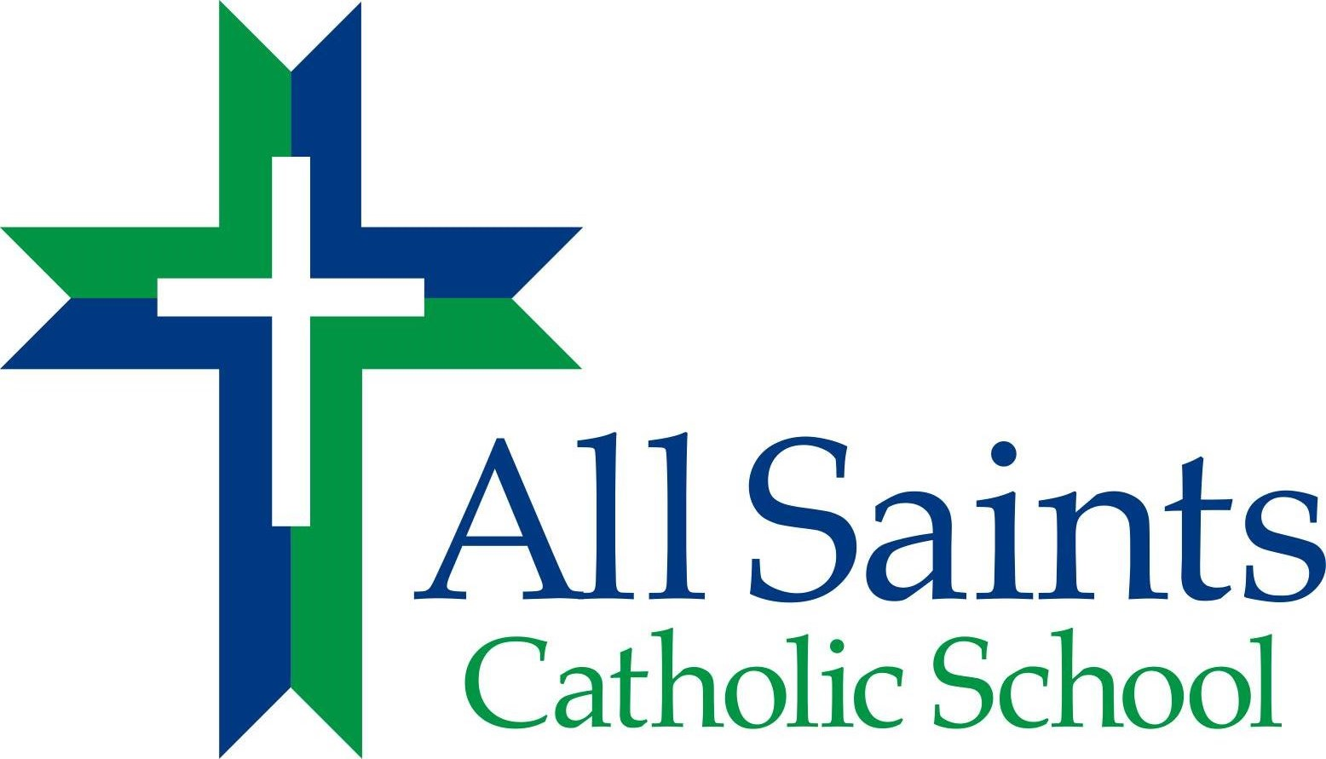

TUITION AND FEE SCHEDULE 2019 - 2020

NEW FAMILY APPLICATION FEE - $150 PER FAMILY
Open Enrollment begins at 8 am on Monday, November 19, 2018

RE-REGISTRATION FEE - $100 PER FAMILY
Re-registration for current families, January 3 –31

*This Fee, in addition to the Admissions Contract, must accompany the Re-Registration/Application Form and is Non-Refundable*

CATHOLIC NON-CATHOLIC
TUITION $6850 $7100
(includes CURRICULUM FEES)

_____________________________________________________________________________

10 Month Payment $685.00 $710.00
(August - May)

**All tuition payments must start either August 5th or 20th**
__________________________________________________________________________________________

Please note that the above monthly rates should be used on the FACTS Application Frm.
(There is a one-time $37 FACTS Fee collected by FACTS prior to the first payment)

All Families must pay tuition through the FACTS program. The only exception is those ofamilies that choose to pay the entire tuition for the year (at a 2% savings) to the school no later than August 1, 2019. To enroll in FACTS for tuition payments, please visit https://online.factsmgt.com/signin/3R2N0.

For families with more than one child enrolled, the tuition will be $1600 per year less for each additional child.

